Women Creating Community

In 2019-2020, the Women Creating Community group was cut short with the pandemic. Since that time, we have cautiously explored beginning again; however, concerns about the virus have kept us from moving forward.

In 2023, the virus is still a concern, but we now have vaccines, good screening, and effective treatments. For this reason, Camp Mack is ready to restart this truly important ministry.

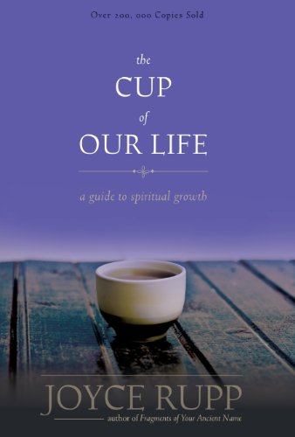
Rosanna McFadden, pastor of Creekside Church of the Brethren in Elkhart, Indiana will be the leader for a half-year study of the book, The Cup of our Life, by Joyce Rupp. Rosanna has been a leader and regular participant in Women Creating Community for many years. She serves as a member of the Mission and Ministry Board of the Church of the Brethren and has preached during worship at Annual Conference. She is excited for this opportunity to reconnect with WCC.

Scheduled meetings for this winter/spring are:
- February 23, 2023
- March 16, 2023
- April 20, 2023
- May 18, 2023

Each day will open with the group together at 9:00 AM. Individual prayer and meditation will complete the morning. All will gather for lunch, and individual time will resume afterwards. The group will reconvene for closing prior to dismissal at 3:00 PM.

Each participant will be responsible for obtaining her own study book which can be readily found at Amazon and other bookstores.

We are so glad to begin this important ministry again and look forward to seeing you here for the first part of this year. Your fee of $200 will include use of camp facilities and spaces for group and individual time, lunch each day, and CEU’s if requested. Please register by February 3rd, so we can be sure there are enough participants.

Next fall, we will begin our regular full year program with 4 sessions in the fall of 2023 and four sessions in the winter/spring of 2024. We can’t wait to welcome you back to the sanctuary of Camp Mack!

